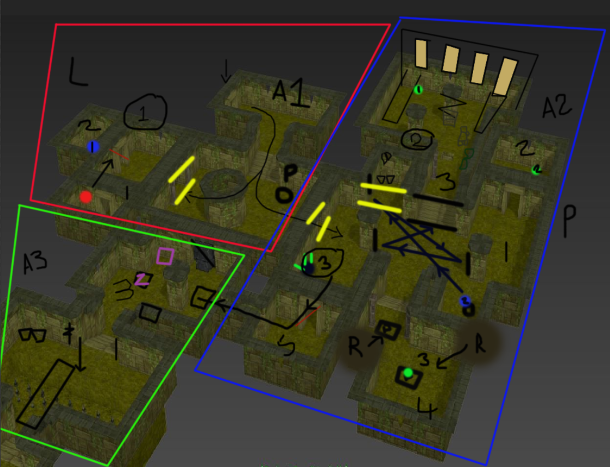Jungle Level Placement / Game play

(This is a plan of how the game will be played and where objects will be placed, some objects can be interacted with, I will explain each key and what its purpose is)

**Area one :**  
*Left area and right area:*   
Once the player starts the game they enter a small room with cracks on the walls where light will beam through. This entire level has a jungle theme, the player would’ve already played the fire and ice levels and learnt different skills, to be able to enter this area. In this level the player gets taught a new skill (The player can break walls without needing mirrors, but they must find the correct walls to do this). As they walk down the stairs, they can see that they’re boxed in, like a dead end. The item holding the power will be placed to the right (from our perspective) There will be a faint glow to it, so the player knows they can interact with it. Once they have the power of destruction, they can now go up to the three walls and try to break them. One of the pathways are blocked by a pile of rocks, the player can see that there is light on the other side, but they need to work out how to get there. Only the left door and right door will have destructible walls, this is the first part of the learn, practise, master loop. The player will practise the power as soon as they get it. If the player takes a left, they will walk into a small room (Left area) but if they decide to go right first, they will see there is an object that needs a blue light before it will light up and reflect onto the mirrors. They cannot progress in the right room until they have found the blue light.   
  
Left area  
In this small room, it will be full of foliage, big leaves and spider webs. There are two doors, one of them, the passage is open, the other door is locked.   
  
Room one:  
In room one there will be urns, wood and spider webs. Within the spiderweb will be a red key.  
This red key will be used on the door, outside room two.

Room two:   
Inside room two, once the door is unlocked, they will find a blue light. (If they have been to the right side of the room, they will know where it is meant to be placed), if they haven’t explored the right area of the temple, they may carry it with them, but it has a timer and it may run out if you don’t walk straight to objective requiring light. The timer will deplete slowly, but it will give the player enough time to get over to the other side.  
  
**Area two:**  
  
Right area:  
As the player approaches the objective, there will be a small yellow beam, showing the player where to place it. Once the blue light has been placed, there will be audio feedback: There will be a cracking sound and it will also deliver visual feedback: The wall in front, guarding the stairs, will open slightly. This will show the player that there is something in the next room, they now know that is their next objective.   
  
On the bottom left of this area, the player will find a ……. With 3 feathers in her head. These feathers will have half the opacity, to indicate that they are missing. (They will have a green glow around them as the feathers are green). The player must find the three feathers in area two, to unlock the next door that takes them to the final area (behind the rock pile).   
  
This area will be foliage heavy, with rocks and spider webs to keep the jungle aesthetic.   
  
Room one:  
In this area, there is a hidden wall, that the player needs to find. (Practise: How to find a wall out of place and destruction) This wall has been placed in front of one mirror, so the player needs to break the wall to have the light reflect.  
  
As the wall has now opened slightly, they should be able to remember what they have done in the previous fire and ice levels, that they need to use mirrors to reflect light, to break the walls. (The player will also remember that they now have a destructive power) There are only two mirrors in front of the player however, the light is only pointing, towards a wall. (The beam of light can’t touch the other two mirrors as they are facing opposite each other) This should indicate to them that they need to get rid of the wall to find the third mirror.   
  
When they reach the wall, a button will appear, telling the player to break it. (This needs to be play tested as we don’t want our players to get bored of us telling them what to do, they could want to explore the rest of the area, before interacting with this.)

Room two:  
This small room, only contains one of the green feathers, As we don’t have an inventory system, these will have to be carried over to the …… and placed inside. These have a small timer, but the player can take their time. Once the player has placed the green feather inside, there will be visual feedback of one of the three feathers being filled with colour.   
  
This room will have three leaves and broken wood.   
  
Room three:  
This room only becomes accessible, once the wall has been broken by the mirror puzzle. This room needs to be expanded, as there are new walls to show height, these will let in a lot of light, so the player can see clearly.   
  
This room has a feather hidden within. As I am thinking about adding more platforms, this will allow the player to explore from high up. I will place the feather in a high place, where it is visual to them. The room will have pressure plates, which they need to avoid. If they stand on them, a rock will fall. (Like a booby trap).   
  
I am also thinking about having more destructible walls in this room. As it is meant to be the practise area. (they will already know how to identify the walls, from the previous puzzle).   
  
In this room, there will be chairs, shelves, pots, urns and extra foliage. (To show someone once lived in this area (sign of life)).   
  
Room four:  
This area can be accessed by the player, almost immediately, (it doesn’t matter which way they find the feathers). This small area will have two or three pressure plates. (If they have already been   
Room three, they will know that they fall and roll, if you interact with it) If they don’t know what the pressure plates do, they will have to stand on them (and risk death) or find something to push onto it. In the same room there will be chairs that the player can push, this can be used on pressure plates.   
  
Room Five:  
This area will be unlocked, once the player has found all three feathers. There is a little passage way that will lead them to Area Three, on the right side there will be a respawn point.   
  
**Area three:**  
  
Room one:   
This room has three pressure plates, one of the three needs to be held down constantly. Once the plates have been pushed down, a bridge will fall on top of the spike pit in front of you. There will be a chair (Or a boulder) to push onto the plates. Two of the plates are booby trapped with boulders however, the player will already know how to avoid them because of the previous areas in the level.   
  
Room Two  
In this small room, the player will find a purple key (The players should now know it is for a lock). This key is for room four.  
There are two shields on the wall, I added these to the front of the final area to show it has importance. Once the player enters room three, there will be a boulder that falls behind them, trapping them in this area.   
  
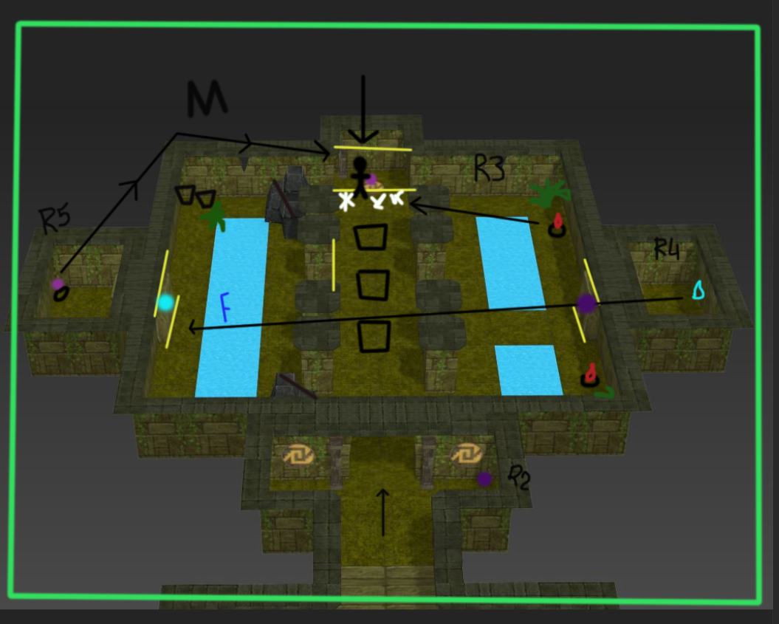Rooms three, four and five:  
 This room is important. I was planning on having the characters ‘sister’ trapped behind a destructible wall. Where she is going to make the sacrifice (Narrative). Once the player walks into the room, there will be audio feedback: girl moaning in pain or mumbling. The player can choose to go towards the sound or work their way around it.  
  
 If they go straight forward, they will walk onto pressure plates (Repetitive as they already know what’s coming. This is the master room, where they should already know how to prevent death)   
  
On the left they will see the same rock pile as they did at the start of the jungle level, the player can see beyond them, but they can’t get past. In between the columns there will be a destructible wall that they must destroy, this will then make an opening. The only way around the water in front of them, is to freeze it, like they did in the ice level. This will then take them to a long wall (there will be a destructible wall within all the walls, where they will come across a door). The player will probably walk up and down (need to know through playtesting) and try to interact with the wall. There will be a blue key symbol, showing them that they need the key to get inside.   
  
The player can also go to the right side of the area, where they will find a similar area but this time there are two fire pits (Like in the fire levels). There’s a long wall on the right with a destructible wall, attached to it. Once the player has interacted with the wall, they will come across another door, this time with a purple key on it. The player needs to receive the purple key from room two and unlock it. Inside this room there will be a blue flame, that can be used to unlock room five. But they have a timer, to get it over to the other side (this is why they need to destroy the two walls in the front, before you can walk across the path) Once the player has entered room five, they will see a shiny purple gem… (with the character’s sister’s name on it). The audio will appear louder in this room. The gem needs to be given to his sister to complete the sacrifice. (Or will they? (Narrative))   
  
The sister is located at the back of room three, to remove the spider webs, the player must interact with the fire pits (like the fire levels) and then the player can remove the wall in front of sister.   
  
(Cut scenes? Temple starts collapsing? Fire starts? Rescuing the sister? End of game?)